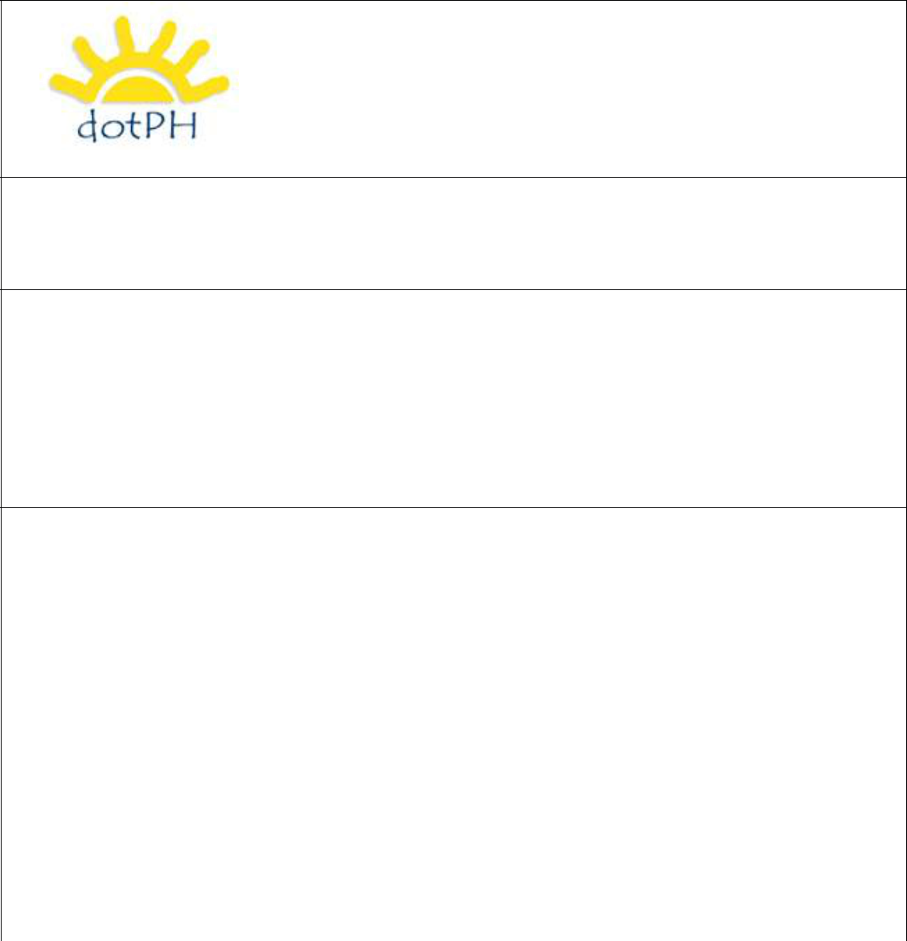

The Official Domain Registry of the Philippines

Email Address
Change Form


Instructions:

- Please make sure all fields are completed in full, PRINTED format.

- The registrant must sign for the form to be valid and one (1) valid government issued photo identification (ID) shall be required.

- Please send this completed form as email attachment to helpdesk@dot.ph.
- We may require additional documents to process this request.

- For inquiries, you may email helpdesk@dot.ph or call +632-6372104/05 between Mondays to Saturdays, 9:00 am to 6:00 pm (GMT +0800).

 | Domain Name
 | Email Address
 |  | Name (Last, First)
 | Registrant | Address
 | Contact
 | Contact | Country
 | Information | Country
 |  | Phone Number
 |  | (+country - code area code – phone no.)
 |  | Signature
 | Signature Block | Signor’s Name
 |  | Signor’s Position
 |  | Date


Terms and Conditions:

I have read, understood, and agree to the Terms and Conditions specified in the Domain Name Service Agreement on www.dot.PH that is in effect as of the date of this application, as well as the dotPH Policies, including but not limited to, the Domain Name Dispute Policies.

